Viking Motorsports Digital Dash

Test Plan

1/30/2015

V 1.2

Sean Koppenhoffer

Noah Erickson

Rishal Dass

Jaime Rodriquez

Chad Thueson

Table of Contents

**Objectives1**

Purpose1

Scope1

References1

**Requirements for Test**2

Function Testing2

User Interface Testing2

Performance Testing3

Load Testing3

Stress Testing3

Robustness Testing3

**Test Strategy**3

Testing Types3

Function Testing3

User Interface Testing4

Performance Testing4

Stress Testing4

Load Testing5

Robustness Testing5

**Testing Equipment**5

**Resources**6

**Appendix Test Record Sheets**7

Functional Test Cases7

User Interface Test Cases8

Performance Test Cases9

Load Test Cases9

Ruggedness Test Cases10

**Objectives**

* 1. **Purpose**

This document describes the plan for testing the prototype of the Viking Motorsports Digital Dash. This Test Plan document supports the following objectives:

* Identify existing project information and the software and hardware that should be tested.
* List the recommended test requirements (high level).
* Recommend and describe the testing strategies to be employed
* Identify the required resources and provide an estimate of the test efforts.
* List the deliverable elements of all tests.
  1. **Scope**

This test plan describes the integration and system tests that will be conducted on the Viking motorsports digital dash following the integration of subsystems and components identified in the Design Considerations for prototyping document [1].

The purpose of this test plan is to test the feasibility and performance of the Digital Dash. It is critical that all subsystems be tested before integration into the system so as to ensure a proper user experience when using the digital dash is integrated into racing vehicle.

The following modules and interfaces will be tested:

* CAN message interpretation
* Data transmission to LCD
* GUI on LCD screen

Critical performance measures to test are:

* Minimal time to capture and interpret CAN data
* Time to display data on LCD screen after data interpretation
* Initialization time before the digital dash is ready to use
  1. **References**

1. [Design Considerations, Version 1.0](https://github.com/noahterickson/DigitalDash/wiki/Design-Considerations)
2. [Digital Dash for an Electric Race Car](https://github.com/noahterickson/DigitalDash/blob/master/Requirements/Digital_Dash_Capstone.pdf)
3. **Requirements for Test**

The lists below identify items (functional requirements, non-functional requirements and use cases) that have been targeted for testing. This listing represents what will be tested.

* 1. **Function Testing**
* Project requirements: The system must be powered by a 12V source
* Data from CAN network is being relayed to Arduino Due for analysis.
* Data from Arduino Due is being sent to LCD display.
* Data is being properly interpreted and displayed in GUI on LCD display.
  1. **User Interface Testing**
* LCD screen must be viewable in sunlight.
* Project requirements: “The digital dash should be easily readable, big fonts, non-cluttered display.”
* The following variables must be displayed on the LCD screen
  + Main battery voltage
  + PMI100 temperature
  + Max Cell temperature
* The following Warnings must be displayed on the LCD screen
  + Main battery voltage low
  + PM100 temperature high
  + Max cell temperature high
* The following errors must be displayed on the LCD screen
  + Battery voltage below limit
  + PM100 temperature above limit
  + Max cell temperature above high
  + BMS error
  + Insulation Monitoring Device error
  + PM100 error
  1. **Performance Testing**
* Project requirements: “The unit must boot up in less than 30 seconds.”
  1. **Load Testing**
* Verify system response when CAN network heavily loaded
  1. **Stress Testing**

None.

* 1. **Ruggedized Testing**
* Requirements Document: “The unit must be weatherproof.” [2]
* Ruggedized to survive one season of racing.

1. **Test Strategy**

The test strategy is the recommended approach to test the hardware and software. The previous section described what will be tested. This section describes how it will be tested.

* 1. **Testing Types**
     1. **Function Testing**

The goal of these tests is to verify proper data acceptance, processing and transmission. This testing is based on black and white box techniques. These tests are to check that modules can handle typical situations.

|  |  |
| --- | --- |
| Test Objective: | * Ensure proper data entry and processing and transmission. |
| Technique: | * Execute each use case, case flow, or function, data, to verify the expected results occur when valid data is used. |
| Completion Criteria: | * All planned tests have been executed. * All identified defects have been addressed. |
| Special Considerations: | * N/A |

* + 1. **User Interface Testing**

User Interface testing verifies a user’s interaction with the software. The goal of this testing is to ensure the UI provides appropriate feedback.

|  |  |
| --- | --- |
| Test Objective: | * Verify the following: Ensure LCD screen displays information properly on the screen and is visible to the driver. * Verify that screen is readable in sunlight |
| Technique: | * Predefined messages are broadcast over the CAN network and the corresponding information should be displayed onto the screen * Take unit outside and see if screen is readable |
| Completion Criteria: | * All user interface modules functioning properly * All identified defects have been addressed |
| Special Considerations: | * If visibility of screen in sunlight is sub-par a new type of screen will need to be sourced and all interface testing will have to be repeated. |

* + 1. **Performance Testing**

Performance testing measures the transaction time and other time sensitive requirements. The goal of performance testing is to tune the system to ensure that interaction with the system is not excessively slow and doesn’t use excessive energy.

|  |  |
| --- | --- |
| Test Objective: | * Validate System Response time for designated transactions. |
| Technique: | * Measure the time it takes to perform predetermined operations to ensure they complete within a satisfactory time range. |
| Completion Criteria: | * Completion of operation is found to be satisfactory based on predetermined time range |
| Special Considerations: | * N/A |

* + 1. **Stress Testing**

This section is not applicable to test the Digital Dash prototype.

* + 1. **Load Testing**

Load testing measures the ability of the system to function properly under different workloads. The goal of the load testing is to determine and ensure the system functions properly beyond the expected maximum workload.

|  |  |
| --- | --- |
| Test Objective: | * Validate System Response time for designated operations. |
| Technique: | * Saturate CAN network with data to determine if data can properly be captured and processed. |
| Completion Criteria: | * Data still properly displayed on screen without system locking up or becoming unusable. |
| Special Considerations: | * NA |

* + 1. **Ruggedness Testing**

Ruggedness testing verifies the operation of the unit while meeting Formula SAE Rules requirements and sponsor design requirements.

|  |  |
| --- | --- |
| Test Objective: | * Verify unit adheres to requirements of Formula SEA Article 7 EV7.3.3 * Ensure meets any additional ruggedness requirements |
| Technique: | * Physical tests to ensure that enclosure can function after being exposed to water for 240 seconds |
| Completion Criteria: | * System is still operational after all tests have been completed. |
| Special Considerations: | * Exposed to water means rain like conditions not immersion |

1. **Testing Equipment**

Equipment needed to carry out testing.

* Windows compatible PC
* Viking Motorsports electric race car
* EVCU programming software
* Spray hose

1. **Resources**

This section presents the recommended resources for testing the Digital Dash prototype.



1. **Appendix Test Record Sheets**
   1. **Functional Test Cases**

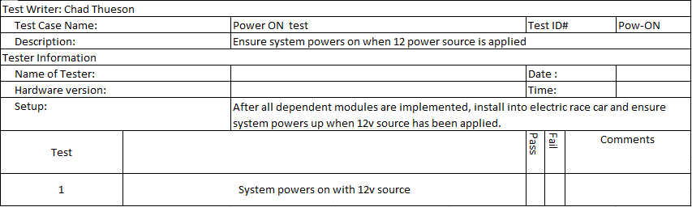**Test case for Power on**

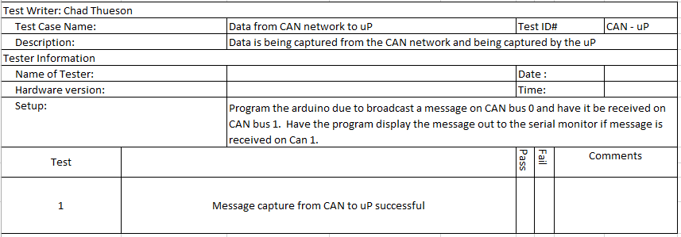

**Test case for CAN to uP**

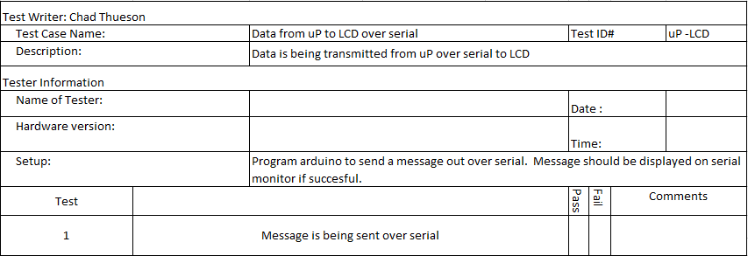

**Test Case for uP to LCD**

**6.1 cont.**

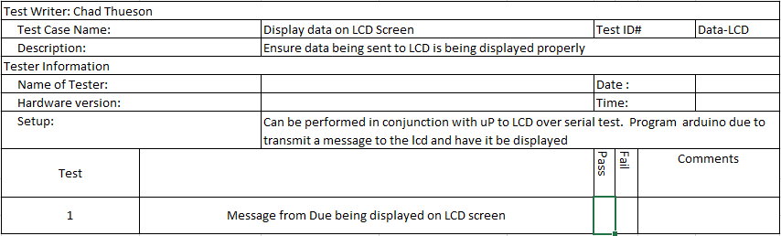**Test Case for displaying data on LCD screen**

* 1. **User Interface Test Cases**

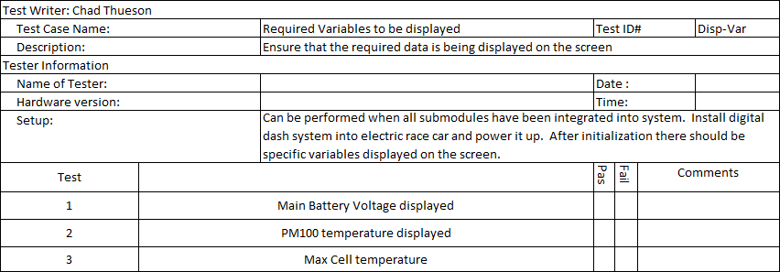**Test Case for required variable**

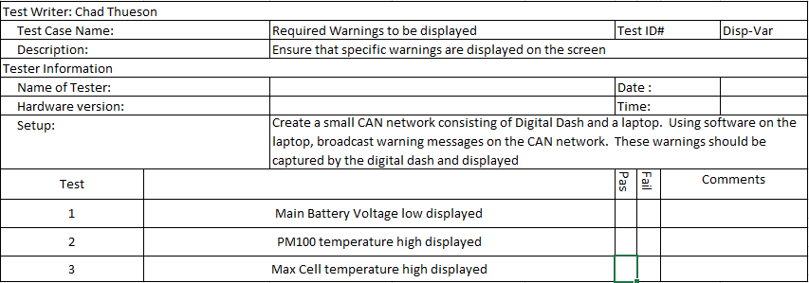**Test case for warnings displayed**

**6.2 cont.**

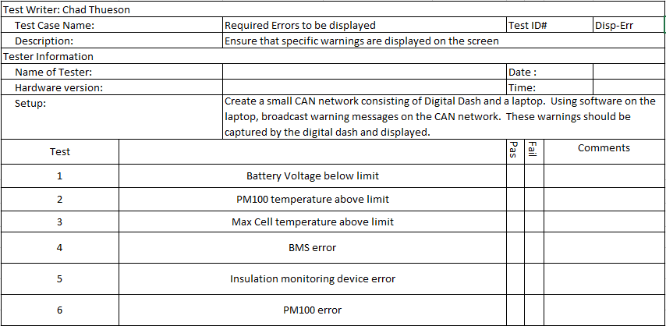**Test case error display**

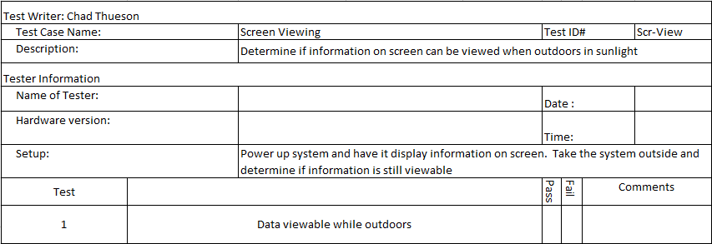**Test case for screen viewing in sunlight**

* 1. **Performance Test Case**

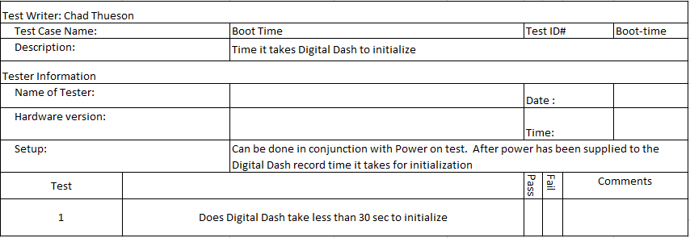**Test case for system boot time**

* 1. **Load Test Case**

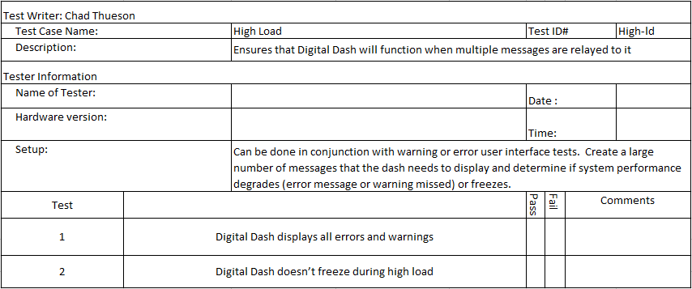**Test case high load**

* 1. **Ruggedness Test Case**

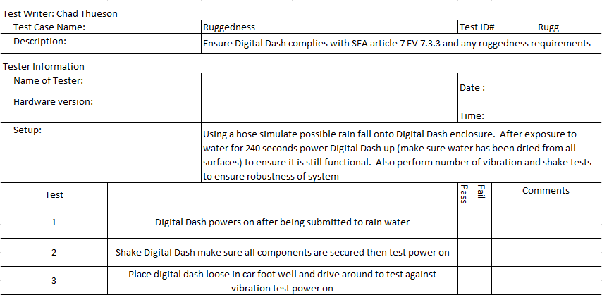**Test case for ruggedness/robustness**